The time has come!
Puppy pick up is Just Around The Corner!!
Puppy contracts and invoices will be sent out via DocuSign for electronic signatures soon. Please take some time and review the contracts. Please let me know if you have any questions prior to signing the contracts. Please sign the puppy contract as soon as you are comfortable with the contract. We would love to have all contracts signed ahead of time so that there is less to do on puppy go home day. Especially with puppy go home day being COVID19 style.
As soon as we know which puppy you are taking, we will sign our portion of the contract and enter the microchip number to the contract as well. Once both of us have signed the contract with the correct microchip information, DocuSign will email both of us a fully executed contract in a PDF format. It’s super easy!
Our Address Is:
Address and directions 5605 NE 179th Street Vancouver, WA 98686
Our new home is easy to find! If you are coming from I-5 you will take exit 9. Exit 9 is the Clark County Fairground Exit, Ridgefield. Head east and drive 2.2 miles. Our home is on the right. We just painted the mailbox RED so it would be easier to find us. The gate at the front will be open and we will be ready!
I am totally re-writing all of our documents these days to accommodate a safe puppy pickup for everyone. Please know that normally puppy pickups are fun and entertaining and a moment you and your family will remember forever. We are doing our best to keep the fun level there and make each family feel special with their puppy pickups. Covid style puppy picks have changed dramatically. In many ways I think the changes that have been made are for the better. At first I was not liking them at all but we’ve made some dramatic improvements as time goes on. I think you will be happy and hope that you appreciate the care that goes into each puppy pickup/orientation. Puppy pickups take at least 3 times more time COVID style but each family gets some individual time which I’m really enjoying. Much calmer than having 20 people in our home all at once. Getting to spend the time with the families and answer questions and just getting to take the time to get to know everyone is a really important part of this process for us.
Puppy Pickup COVID19 style:
We normally have a 60-90-minute new puppy orientation in our living room with all families present at one time. With COVID19 that simply is not possible at this time. So, we’ve created a PDF file for everyone to review. I am asking that you make sure you have the time to go through this documentation before you pick up the puppy. I am also asking that you PLEASE take the time to read this documentation thoroughly before you email me with any questions. When you start to read through this information please take notes. If you have any questions, I want to answer them for you. The puppy orientation PDF will
cover everything that we normally cover at the puppy orientation in our home – minus any questions that come up from families. I’ve tried to include as much as I can think of. And as new questions come up, I go back and add them to this document for future families.
We ask that while you are here if you pick up a puppy please be CAREFUL!! We had a visitor last summer that was standing on concrete holding a puppy and
the puppy wiggled and caught them by surprise and landed on his head and got a trip to the ER. Children need to be sitting on the ground if they want to hold the puppies. It’s just too dangerous. Puppies wiggle way too much. I’m happy to work with your children to teach them the proper way to hold a puppy so that they are more confident and aware of the potential dangers involved with having a puppy leap out of their arms.
Puppy Allocation:
We have never allocated puppies to families before. Many breeders do this on a regular basis. This is just not something we’ve done before. However, I am actually LOVING our new process… so possibly this is one good outcome from COVID. I think it causes everyone to put much more emphasis on their lifestyle and the disposition of the puppy and the integration of a puppy into a home. So, we are going to ask a few questions. Please be as detailed as you can and give us as much information as you feel we need to help pick your future puppy.
- How active is your family? Do you walk daily? Hike on the weekends?
- Do you intend on doing any kind of therapy work and or is your puppy intended to be a service dog?
- Please explain the dynamics in your home and who your family is comprised of and ages.
- Are you looking for a puppy that can keep up with you or are you wanting a couch potato?
We always have our litters evaluated by a third-party specialist, Pat Hastings. She is actually a world renowned AKC judge that just happens to live local to us. She evaluates each of our litters. This in turns helps us to select the best of the litter for breeding stock. By us keeping the best structure of the litter and only breeding to our best boys we will in turn make better structured puppies as the future litters arrive. The puppies will be evaluated by Pat Hastings, once they are +/- 3 days of 8 weeks old. At that time, we will know who our breeding prospects are, and we will be able to move forward with puppy allocation. Sometimes we get lucky and every puppy in the litter has superb structure and are all breeding quality. Sometimes, there are no puppies that should be retained for breeding. And sometimes it’s in between. Just because a puppy is not breeding quality doesn’t mean it won’t make a fantastic service dog, therapy companion dog, family pet. We will take photos a few days before puppies are to go home and then I will reach out to each family on a personal level. Puppy allocation will still happen in the order in which deposits have been received. This is a great litter so I’m pretty confident that everyone will be happy with the outcome. We will try to do our best to place these puppies as we feel they will be best suited for your family. You will definitely have an input into the situation, but we will NOT be placing puppies with families based off of looks alone. So, please reframe from emailing, texting me and or calling me and telling me that you only want the red one with one left white paw with the heart of its butt, with the white tipped tail and one blue eye. (Not that there is one, but I hope you get the drift)
I NEVER want a family leaving feeling like they got the left-over puppies. There is NO SUCH THING in our home as a LEFT-OVER puppy. All of these puppies are beautiful and just a buddle of love. All of these puppies will have an opinion of you as well as I’m sure you will of them too.
We have now been doing COVID style pick up since, March. It’s actually going a lot better than I thought it was going to go. I think I actually like certain aspects of it better than our previous method of puppy pickups. It still makes me nervous picking puppies for families. But I feel fairly confident that we know these puppies really well by the time they’ve been here for 8 weeks. And so far, it’s just worked out super! I do think that the personal time we get with each family has improved over having large group pickups...so that part I’m thrilled with.
If we have puppy allocation completed prior to puppies going home, then I am asking that everyone take two minutes and register your puppies’ microchip prior to picking up the puppy. I am still trying to get people to register their pups’ microchip from 5 years ago! Microchips are an important part of this process. No need to microchip them if they aren’t going to be registered to you. A microchip is one of those things that you are not going to think twice about until a situation comes up and you NEED it! The puppies will not leave here without their chip being registered. Recently, all litters have been allocated at least 24 hours prior to pick up. If a situation arises and we cannot allocate until you are here, we will provide you with a computer to register your chip before you leave. We want to be responsible with this process and frankly I’m tired of people not registering their chips, their dogs come up missing and sometimes I’m 2000 miles away and all I can do is start the process of locating which microchip belongs to which puppy. It puts my heart into a panic each time and this is the best solution I’ve been able to come up with.
Please visit https://www.akcreunite.org. This is IMPORTANT. For some reason people have not been registering their microchip and to me this is really dangerous. Reunite has my contact information on file. So, they will always be able to reach me, but I may not live so close to you and if your puppy gets lost you want to be reunited with your pup as soon as possible. So, we are requiring that each puppy will be registered prior to leaving. You will need a credit card to complete this process. AKC Reunite charges a one-time registration fee. I will provide the microchip number to you in the contract. Once I know which puppy you will be receiving, I will sign the contract and add the microchip number to the contract. Once you receive a DocuSign PDF contract from me your microchip number will be on page one near the top of the contract on the left-hand side. We do ask that if we have provided you the microchip number prior to puppy pick up that you please take just a moment and register the chip prior to picking up your puppy. We are attempting to implement a new policy of puppies do not leave our home unregistered. Thank you for your cooperation with this matter.
We will have Trupanion Insurance binders ready for you. You are receiving 1 month of free pet insurance for you puppy. In order to take advantage of the 30-day free trial for insurance with Trupanion you must call in and register your puppy within 24 hours of puppy pick up. We always recommend that everyone register your puppy before you leave our house. That way you do not get busy and forget to do so. I highly recommend that everyone keep pet insurance for at least the first year. During your first year you will be getting immunizations and several vet visits through this process. Not to mention you will also need a spay or a neuter somewhere between 6-9 months depending upon the restrictions that we are dealing with. Most ER visits are with puppies. The eat stuff... and until you are trained to keep everything picked up and out of reach, I would keep insurance 😊 Not to mention Parvo if your puppy gets Parvo you will want insurance. Parvo usually only happens when they are puppies and not fully vaccinated. A client of ours in California, their puppy caught Distemper. Sadly, the puppy died. But Trupanion covered all the vet bills except the deductible.
We hope you enjoy puppy pick up day. Puppy pick up day is so much fun! It makes what we do the best part. Through our puppies we’ve had the opportunity to meet so many families that we would have never had the opportunity to meet. Have fun and enjoy the puppy time and welcome to the Moonlit Acres family!
Puppy pick up days are the afternoon of 3/17 & 3/18/2021… if you are flying in from out of state please let us know what time your flight arrives and what time you are departing. If you are traveling by car from out of the area please let me know. We will want to try and coordinate your puppy pickup time so that it is at least 2 hours after breakfast or lunch and 2 hours before the next scheduled meal. If you are from Oregon please let me know. If you would like to avoid paying sales tax you can meet your puppy here and complete the puppy pickup process here and then we will meet you and all the other Oregon families at the Target parking lot in Jantzen Beach. Depending upon how many Oregon families there are… there might be a little bit of a wait. We take all the Oregon puppies to Target at the same time. Please let me know right away.
Important information. Your puppy will have a custom collar... Puppy collars are difficult to buy without your puppy being with you. So, we have custom collars made for each baby that goes home. They come in a variety of colors and will be customized. Super cute!
We went to Super Zoo in Vegas in 2019. It is one of the largest pet conventions in the US for pet supplies. And we have lots of stuff available. We have everything from plush/chew toys, food bowls, dog beds available for purchase. We carry Skudo kennels in 3 sizes; 27”, 32” & 36”. A 27” kennel should work for a mini pup for their entire life. 32” for a medium and 36” for a Golden Retriever. If you would like to purchase a kennel, please let me know as we may need to order additional kennels prior to puppy go home day. I really like these kennels. They are hard-sided plastic with quality latches. We also have options of wheels (Which I LOVE) I can scoot my potty-training puppies all over my house and I can also take them into the vet on wheels. Such a nice option to have.

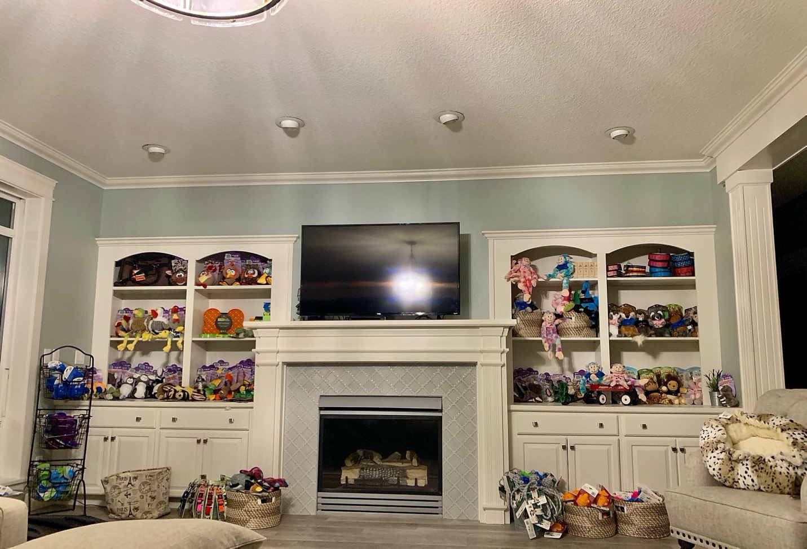
TRAVELING with puppy in airplane cabin: If you are traveling in on plane, we have puppy luggage carriers here. We just purchased a large quantity of dog bag carriers. In the past I’ve spent a lot of time trying to help families find the right dog carrier for their plane ride home. We are working to make this process much easier on everyone... plus if we provide the carrier, we can have our mama dog snuggle with the liner that goes on the bottom of the carrier floor, before she goes home. We have carriers available starting at $64. They are super nice carriers and come in a variety of colors and designer fabrics. Each carrier has three openings with mess for breathability. Some have shoulder straps; some can be a backpack and others strap onto your luggage. All of them have safety straps on the inside which I LOVE. If you need a bag just let me know.
We have soft toys and chew toys... we have ordered a TONS of toys. I ordered toys that I know our puppies would enjoy playing with. A lot of the toys that we ordered are toys that have arms and legs and will be great for playing tug of war with. Lots of chew toys!
Dog bowls: we just found a local vendor in PDX that makes portable food bowls so if any of you hikers are going to need a collapsible bowl, we have them. They are great for the car too. We also found a company that was from Australia, that has food bowls that have a prickly bottom to it. It is designed to help scrape bacteria off of your dog’s tongue! They come in orange and green. With us having Golden Retrievers we also got some slow feeder bowls and some “licky mats”. The Licky Mats help keep your dog occupied if have to leave.
COVID19 forced us to throw together an online store. We have literally everything you will need to take a puppy home. Any stuffed animals that you buy we will have the puppy’s mama snuggle with before she leaves. All orders will be ready for pickup on the day of puppy pickup. Here is the site: https://www.moonlitacres.com/shop As we get new items, we will add them to the site. When you are ordering PLEASE make add a note of which litter you are getting a puppy from. THANK YOU!
Really quick note on kenneling and separation anxiety. We start kennel training at 4 weeks of age. We start with short 20-minute naps and work our way up to 90 minute naps. When you take your puppy home the first three nights are always the most difficult. If you get nothing else from our online store, I would recommend getting a Snuggle Puppy. If you preorder a snuggle puppy, we will have mama snuggle with the toy before she goes home. These Snuggle Puppies have a battery-operated heartbeat and heating pads that go inside. The puppy’s moms usually go home when the puppies reach 7 weeks of age. And then at 8 weeks of age the puppies no longer have littermates they now have humans. And now you are going to put them in a kennel at night, all by themselves. These Snuggle Puppies dramatically help the nighttime kenneling process. Highly recommended!
One tradition that we’ve been doing for years is having our families fine a puppy toy and start snuggling with it. Get everyone in the family to get their scent on it. Send it to us by the time the puppies reach 7 weeks of age. This will give the puppies from this litter time to get familiar with your families smell. It really seems to help with the transition to home. Please do not send a t-shirt, blanket, fabric. Toys only. The best toys are toys that have arms and legs that puppies will play tug of war with.
We have been limiting our exposure for what seems like a lifetime. We are doing everything that we can do to keep ourselves safe so that the puppies have a team of people to care for them. If you are feeling sick, please postpone coming or send someone else. At this time everyone is required to wear a mask. Our entire team will be wearing a mask as well.
We are excited to meeting everyone. Puppy pick up days are amazing! So much fun... If you have any questions or if you get lost, please call me on my cell. Again, we are the almost exactly 2.2 miles east of I-5. The gate will be open. 😊
Lastly, here is a link that will provide you with a ton of information. Grab a cup of coffee and make sure you have some time. I’ve had some people tell me that I should modify this to state grab a POT of coffee. J There is information on here regarding food and supplements, training, medical records... just for Belle x Doc’s Puppy Families. Some of the documents on here you will want to download and save as you will want to take them to the vet with you for your first well baby exam. Some of the links will be updated after their well-baby checkup is complete such as the link for the Litter Report. https://www.moonlitacres.com/belle-family
See you soon!
Dana – Moonlit Acres
360-980-1926

